**Project:  Device Driver for BH1750VI a digital ambient light Sensor on Raspberry Pi.**

BH1750 is a Light Intensity Module which works using I2C protocol. Here an I2C device driver to interface this sensor to Raspberry pi 4 is made.

**Summary:**

A kernel module is written for BH1750VI, a digital ambient light sensor IC for I2C bus interface on Raspberry Pi. This IC is the most suitable to obtain the ambient light data for adjusting LCD and Keypad backlight power of Mobile phone. In our project we are writing a kernel space code which uses i2c bus to read values from the sensor and it will be displayed on the kernel log.

The method we are using is I2C instantiation.  The Industrial I/O core offers a unified framework for writing drivers for many different types of embedded sensors. An IIO device usually corresponds to a single hardware sensor and it provides all the information needed by a driver handling a device. A typical IIO driver will register itself as an [I2C](https://www.kernel.org/doc/html/v4.15/driver-api/i2c.html) or [SPI](https://www.kernel.org/doc/html/v4.15/driver-api/spi.html) driver and will create two routines, probe and remove.

**Hardware Design:**

  Please Note that we have used Raspberry pi 4 with Raspbian installed.

**Requirements:**

Raspberry pi 4

Memory Card

Raspbian Jessie (Preferred)

Linux Header installed and compatible with the kernel version

BH1750VI Light Intensity Module

Connecting Wires

Raspberry pi Datasheet

**Connections:**

Connect Vcc of Sensor to 5V pin on Raspberry pi

Connect SCL to SCL pin on board

Connect GND to Ground pin on board

Connect SDA to SDA pin on board

Connect ADDR to Ground pin on board

# Schematic:

**Actual Photograph:**

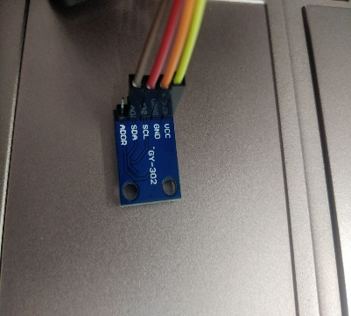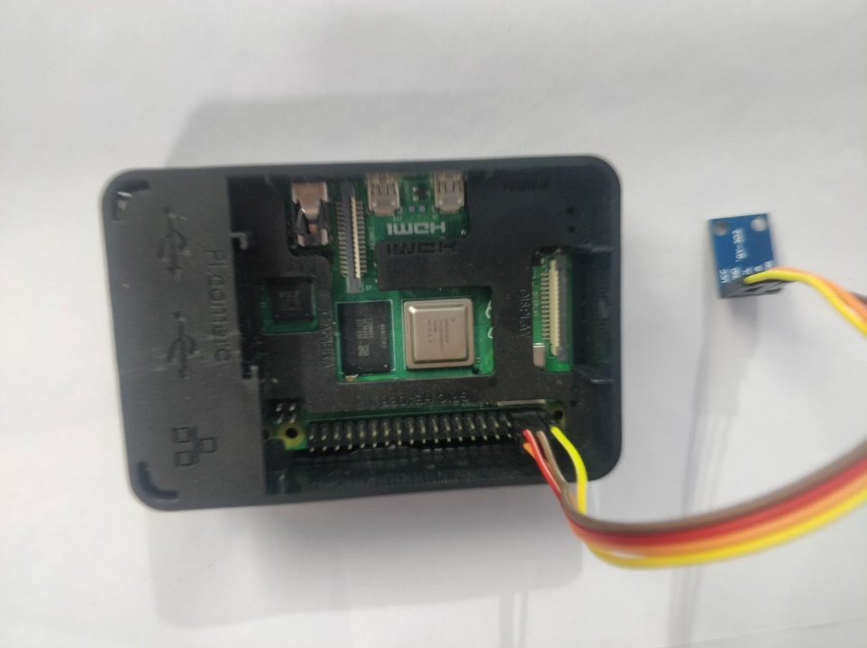

**Initial Testing of Sensor:**

Initial testing includes detecting the address of the sensor. The steps involved are :

1. On the Terminal run $ lsmod
2. Run $sudo apt-get install raspberrypi-kernel-headers which will create a build directory inside the kernel header.
3. If i2c_dev appears in the list go to step 4
4. If it does not appear run $modprobe i2c_dev and check again using lsmod command
5. Assuming that i2c_dev driver is present run $ i2cdetect –y 1

This command displays the slave address of this sensor which is 0x23 for BH1750.

**Code Compilation Procedure:**

Run $sudo make all on the terminal having all files.

1. This generates i2c_pro.ko and chip.ko files successfully
2. Run the command $sudo depmod –a which thoroughly probes and examines all modules in the kernel
3. Insert the module using $ sudo insmod i2c_pro.ko
4. Run the command $sudo modprobe industrialio
5. Run the command  $sudo modprobe chip to insert loadable kernel module into linux kernel as an IIO device
6. The device file should be created under /sys/bus/iio/iio:device*X*/ and /dev/iio:device*X*
7. Run the command $cat /sys/bus/iio/devices/iio:device0/in_illuminance_raw to read the contents of the file in_illuminance_raw on the terminal which is nothing but the light intensity sensor reading.
8. To Remove the module run $rmmod i2c.ko